Event Scanner

<https://github.com/jeryjs/Event_Scan>

# Overview

## Introduction and Purpose

The Party Scan project is a Flutter application developed primarily for event management and barcode scanning. Its main purpose is to streamline the process of ticket entry and attendee management during events such as freshers' parties or multi-day programs. The app ensures that tickets are scanned efficiently and checks for duplicate or invalid scans in real time using a Firestore database. Through a combination of real-time synchronization across devices and responsive user interfaces, the app helps event organizers monitor entry status and manage participant data with ease.

## Dependencies and Their Use Cases

1. **Firebase Core & Cloud Firestore:**  
   The application integrates Firebase to manage app initialization and cloud-based data storage.
   * *firebase_core:* This package initializes your Flutter app with Firebase using settings generated by the FlutterFire CLI (stored in [firebase_options.dart](vscode-file://vscode-app/z:/Applications/Microsoft%20VS%20Code%20Insiders/resources/app/out/vs/code/electron-sandbox/workbench/workbench.html)).
   * *cloud_firestore:* Used to manage the app data on the cloud. It supports operations such as reading from and updating the ticket and event records, ensuring that the barcode scan status is synchronized in real time across multiple devices.
2. **Mobile Scanner:**  
   Barcode scanning is at the core of Party Scan. The mobile_scanner package enables the app to capture and decode barcode images. It is configured to target specific barcode formats (for example, Code128) and leverages the device camera to quickly identify and process barcode data.
3. **Audioplayers:**  
   Sound feedback is an important aspect of enhancing the user experience during the scanning process. The audioplayers package provides capabilities to play distinct sound effects on successful or unsuccessful scans. This auditory feedback helps confirm a successful entry to the user or notifies them in case of an error (e.g., duplicate scanning).
4. **Flutter Launcher Icons:**  
   This package is used to dynamically generate the app icons for different platforms (Android, iOS, desktop, etc.). The configuration in the [pubspec.yaml](vscode-file://vscode-app/z:/Applications/Microsoft%20VS%20Code%20Insiders/resources/app/out/vs/code/electron-sandbox/workbench/workbench.html) ensures that the launcher icons are properly set up and adjusted for each platform, contributing to the app's professional look and consistent branding.
5. **Flutter IconPicker & Flutter ColorPicker:**  
   User interfaces in the Party Scan project incorporate customizable elements for a better user experience.
   * *flutter_iconpicker:* Allows users or developers to select and display icons, making it easier to personalize the UI components based on event themes or user preferences.
   * *flutter_colorpicker:* Provides an interactive color selection tool, which is especially useful in components like day headers or the app’s dashboard to match the event’s color scheme.
6. **Flutter Staggered Animations:**  
   Smooth UI transitions and animations enhance the overall look of the application. The flutter_staggered_animations package is used to create progressive and visually appealing animations. This is particularly relevant in lists and dynamic elements that update in real time during user interactions.
7. **Flutter Slidable:**  
   For more interactive list displays, the flutter_slidable package enables slide-to-reveal actions on list items. This is particularly useful for sections displaying scanned barcodes or user details, allowing quick interactions such as editing or deleting records with intuitive swiping gestures.
8. **File Picker & Excel:**  
   Data import and export functionalities are crucial for event management applications.
   * *file_picker:* Helps in picking files from the device, which is useful when administrators need to import barcode data from external sources or update event configurations.
   * *excel:* Facilitates the export of scanned data and reports in Excel format, making it easier for organizers to generate offline reports or share event summaries after the event.

## How It All Works Together

* **Startup and Initialization:**  
  The application starts by initializing Firebase with the provided options from [firebase_options.dart](vscode-file://vscode-app/z:/Applications/Microsoft%20VS%20Code%20Insiders/resources/app/out/vs/code/electron-sandbox/workbench/workbench.html). This configuration is crucial for connecting the app to the backend services and for managing secure data communication.
* **Barcode Scanning Process:**  
  The BarcodeScanner widget encapsulates the scanning interface. Using the mobile_scanner package, it activates the device camera and focuses on a predefined scan window. Once a barcode is identified, the app queries Firestore through the Database service to determine if the barcode has already been scanned. Depending on the query result, it plays either a success or failure sound using the SoundManager service.
* **Data Management and Synchronization:**  
  All scanned data and event-related settings (such as the current day, event title, etc.) are managed by the Database service, which communicates with Cloud Firestore. This setup ensures that the state of the event (e.g., which barcodes have already been scanned) is consistent in real time across all devices accessing the app.
* **User Interface and Visual Feedback:**  
  The UI is built using various Flutter widgets, each responsible for a piece of the application (e.g., the home screen, scanner view, dashboard report). Custom animations and transitions (using flutter_staggered_animations and standard Flutter animations) create a dynamic user experience, while dialogs and bottom sheets (for instance, in the ResultDialog and BottomBar components) provide clear and immediate feedback to user actions.

# Working

### A screenshot of a phone Description automatically generated1. Home Screen

**Overview:**  
The Home Screen is the initial interface where users launch the app. It displays key information such as the event name, current day/session, and quick access to app functionalities.

**How It Works:**

* **Navigation and Status:**  
  The top area of the screen usually contains the event title and current status (e.g., "Day 1", "10 Days To Event Start"). This gives users an immediate context on which event session is active.
* **Action Buttons:**  
  Users find clearly marked buttons that navigate to the scanner, view reports, or access settings. Each button is linked to its respective module with Flutter’s Navigator for smooth transitions.
* **User Feedback:**  
  Live data widgets and snack bar notifications keep users informed about the system status (e.g., successful initialization, connectivity issues).

### 2. Scanner Screen

**Overview:**  
The Scanner Screen is where the barcode scanning process happens in real time. In this enhanced version, feedback that was previously shown in a separate result dialog is now integrated directly into the Scanner Screen.

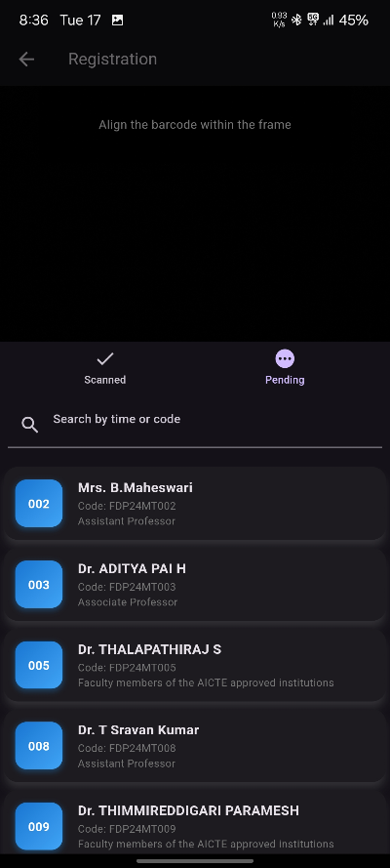

**How It Works:**

* **Barcode Capture & Validation:**  
  The scanner uses the mobile_scanner package to continuously capture barcode data. Once a barcode is detected, it validates the input against the Firestore database. If the barcode is new and valid, the process is labeled as a successful scan; otherwise, it triggers an error state (for duplicate or unrecognized barcodes).
* **Integrated Feedback:**  
  Instead of opening a separate result dialog, visual feedback appears right on the scanner view.
  + A color transition animation using an AnimationController and a ColorTween provides immediate color cues:
    - **Green** for a successful scan.
    - **Red** for already scanned barcodes.
    - **Amber** (or a neutral tone) if the scan status is unknown.
  + Iconography and text messages are dynamically updated on the screen. An icon (e.g., check, close, or warning) and accompanying text inform the user about the scan result.
  + If the scanned result is incomplete (for example, missing user title data), the system automatically triggers an edit dialog using a scheduler callback so that the user can input or modify details immediately.
* **Animation & Transition:**  
  The scanner screen leverages ScaleTransition and AnimatedBuilder widgets to animate the feedback elements. This results in a smooth transition that reinforces the scan status without interrupting the scanning flow.

### 3. Dashboard / Report / Manage Screen

**Overview:**  
The Dashboard Screen offers a consolidated view of event statistics and scanned data. In this enhanced version, it also includes the functionality to manage users, allowing administrators to quickly update and review participant information.

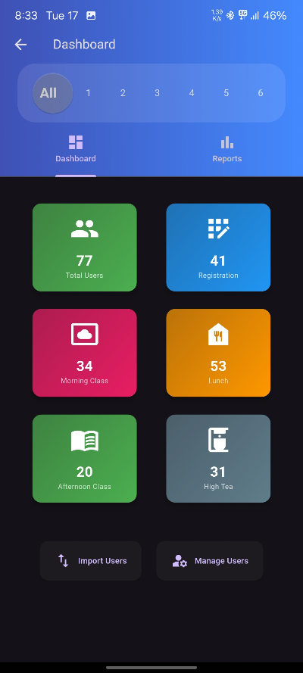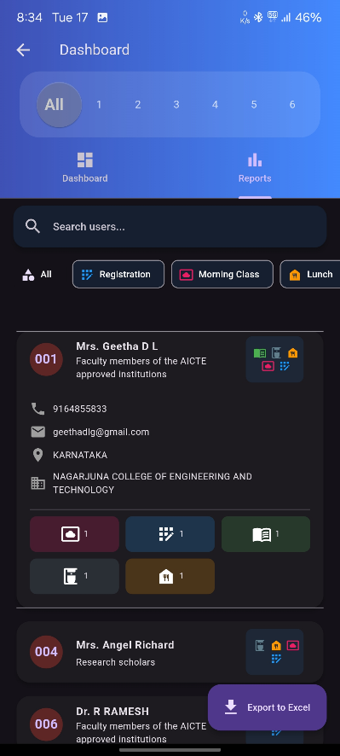

**How It Works:**

* **Data Presentation & Analytics:**  
  Displays statistics such as total scanned entries, error counts, and real-time updates from the Firestore database in both table and chart formats.
* **Manage Users Feature:**  
  A dedicated section or button labeled "Manage Users" is provided on the dashboard. When activated, it opens a user management interface integrated within the dashboard.
  + **User Listing & Actions:**
    - Lists all participants with details sourced from the previously scanned data or from a separate user collection in Firestore.
    - Provides functionalities to edit or delete user entries. In cases where a scanned result was flagged for missing or incorrect data, this section provides immediate access to correct those errors.
  + **Inline Editing:**  
    Similar to how the edit dialog was triggered in the scanner screen for incomplete data, the Manage Users section allows in-place editing. This ensures that updates can be made on the fly without navigating to a different part of the application.
* **Real-time Updates:**  
  Any modifications made in the Manage Users section reflect immediately in the overall dashboard, thanks to real-time synchronization with the cloud database.

### 4. Settings Screen

**Overview:**  
The Settings Screen allows administrators and event organizers to configure application settings and manage various categories used in the event. One key feature on this screen is the "Manage Categories" dialog, which enables users to add, edit, or delete categories that classify scanned results.

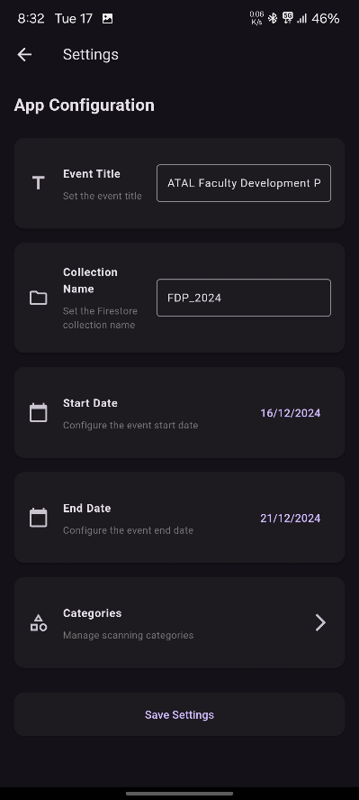 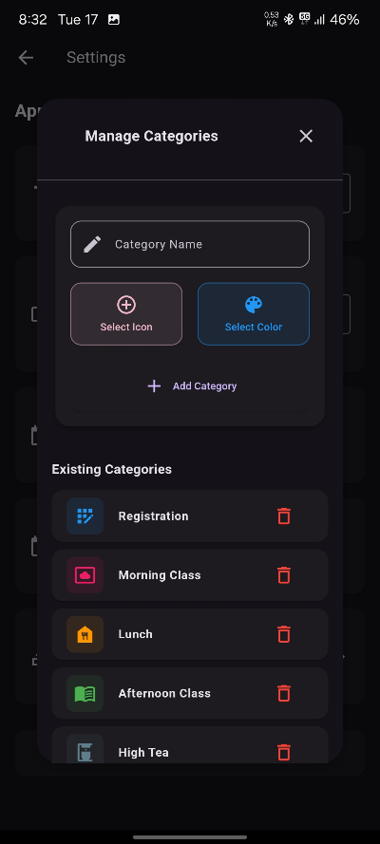

**How It Works:**

* **General Settings:**  
  Options available on the Settings Screen include toggling notification sounds, theme adjustments, and other app-specific configurations that affect both the scanning process and report generation.
* **Manage Categories Dialog:**  
  Integrated into the settings, the Manage Categories button launches a dialog (reusing functionality from the previous dialog-based approach in the scanner screen).
  + **Dialog Functionality:**
    - Loads existing categories either passed as parameters or fetched from the database using a helper function call.
    - Allows editing of category names, colors, and other metadata to tailor the scanning experience.
    - Upon user confirmation, changes are persisted back to Firestore (or a local state) ensuring that updates immediately reflect in the scanning and reporting functionalities.
* **User-Friendly Controls:**  
  The interface is designed with clear buttons, confirmation dialogs, and error validations ensuring that users easily manage categories without impacting the overall workflow of the app.

# Architecture and Implementation Details

## Overall Architecture

The Party Scan project follows a modular architecture divided into layers that separate concerns for better maintainability and scalability.

* **Presentation Layer:**  
  This layer is implemented using Flutter’s widget-based architecture. Each screen—such as the Home, Scanner, Dashboard, and Settings screens—is a well-defined module responsible for rendering UI elements, handling user input, and displaying feedback.
* **Service Layer:**  
  The Business logic is encapsulated in services like the Database service. This service abstracts direct interactions with Cloud Firestore and provides a secure, centralized way to read and write data (e.g., barcode validations, settings, and user data).
* **Data Layer:**  
  Data models such as CategoryModel and user data maps are used to structure the data coming to and from Firestore. JSON encoding/decoding along with helper functions ensure that data maintains consistency when being persisted or transformed.

## Implementation Insights

* **Firebase Integration:**  
  The application leverages Firebase for both initialization (via the [firebase_options.dart](vscode-file://vscode-app/z:/Applications/Microsoft%20VS%20Code%20Insiders/resources/app/out/vs/code/electron-sandbox/workbench/workbench.html) configuration) and real-time data management using Cloud Firestore. Initialization occurs in [main.dart](vscode-file://vscode-app/z:/Applications/Microsoft%20VS%20Code%20Insiders/resources/app/out/vs/code/electron-sandbox/workbench/workbench.html), where Firebase is set up before launching any UI. This ensures that all subsequent interactions with the database have a secure and established connection to the backend.
* **Barcode Scanning and Feedback:**  
  The scanning functionality is implemented using the mobile_scanner package. Upon scanning a barcode, the app immediately queries the Firestore database to check for duplicate entries. The integrated feedback on the Scanner screen uses Flutter’s animation widgets such as ScaleTransition and AnimatedBuilder to provide visual cues (e.g., color transitions, icons, text) based on the validation result.
* **User and Category Management:**  
  The application includes comprehensive screens and dialogs for editing user details and managing categories. The Manage Users Screen allows inline editing using dialogs like EditUserDialog, which ensures that any changes in user data can be validated and saved in real time. Similarly, the ManageCategoriesDialog embedded within the Settings Screen is designed to load, modify, and update categories with minimal friction.
* **Data Export and Reporting:**  
  The Dashboard and Report screens combine Flutter’s animation capabilities (via the flutter_staggered_animations library) and interactive slidable widgets to create an intuitive user experience. In addition, file import and export functionalities are implemented using packages such as file_picker and excel, allowing the app to generate detailed reports in spreadsheet format.
* **Third-Party Packages:**  
  Each package is chosen for a specific role. For example, flutter_slidable provides intuitive swipe actions on list items, while packages like flutter_iconpicker and flutter_colorpicker add to the customization of the UI. These packages are integrated to enhance user experience without compromising the performance or complexity of the overall system.

## Design Decisions

The design of Party Scan places a strong emphasis on user feedback, real-time performance, and error handling:

* **User Feedback:** Immediate feedback through visual and auditory cues ensures users know the result of each action, minimizing ambiguity during high-volume scanning.
* **Real-Time Data Synchronization:** By leveraging Firestore’s live updates, the system maintains consistency across devices and ensures that simultaneous operations (scanning, editing, and reporting) remain accurate.
* **Modularity:** Code reuse is maximized by segregating screens, dialogs, and services into distinct files and modules. This not only streamlines development but also simplifies troubleshooting and further development.

# Deployment, and Troubleshooting

## Deployment Practices

* **Firebase Deployment:**  
  The Firebase backend is managed independently, and configurations in [firebase_options.dart](vscode-file://vscode-app/z:/Applications/Microsoft%20VS%20Code%20Insiders/resources/app/out/vs/code/electron-sandbox/workbench/workbench.html) enable the app to connect to live Firestore and Storage services. When deploying updates, developers update the configuration as required.
* **App Distribution:**  
  Platform-specific build processes are defined in the Flutter project’s configuration files. Using tools such as Flutter’s build runner, developers generate release builds for both Android and iOS. Details such as launcher icons and theme consistency are managed using packages like flutter_launcher_icons.
* **Versioning and Rollbacks:**  
  The project follows semantic versioning. Before deployment, version bumps are tagged and release notes are prepared. In case of any critical issues on production, version control facilitates quick rollbacks to stable releases.

## Troubleshooting and Maintenance

* **Logging and Monitoring:**  
  Detailed logging is implemented to capture errors and exceptions during the scanning process and database transactions. Tools like *Firebase Crashlytics* are used to monitor runtime errors and performance issues.
* **Error Handling:**  
  Graceful error handling is prioritized. For example, if a network error occurs during a Firestore transaction, the app displays an appropriate error message with instructions for retrying. Inline error validations in forms ensure that users provide data in the required format before any database operation takes place.
* **Documentation and Updates:**  
  The project benefits from thorough documentation that outlines system architecture, API references (for Firebase and third-party packages), and issue reportings. This documentation is kept up-to-date alongside code changes via GitHub, ensuring that both developers and users have clear references during maintenance or onboarding.